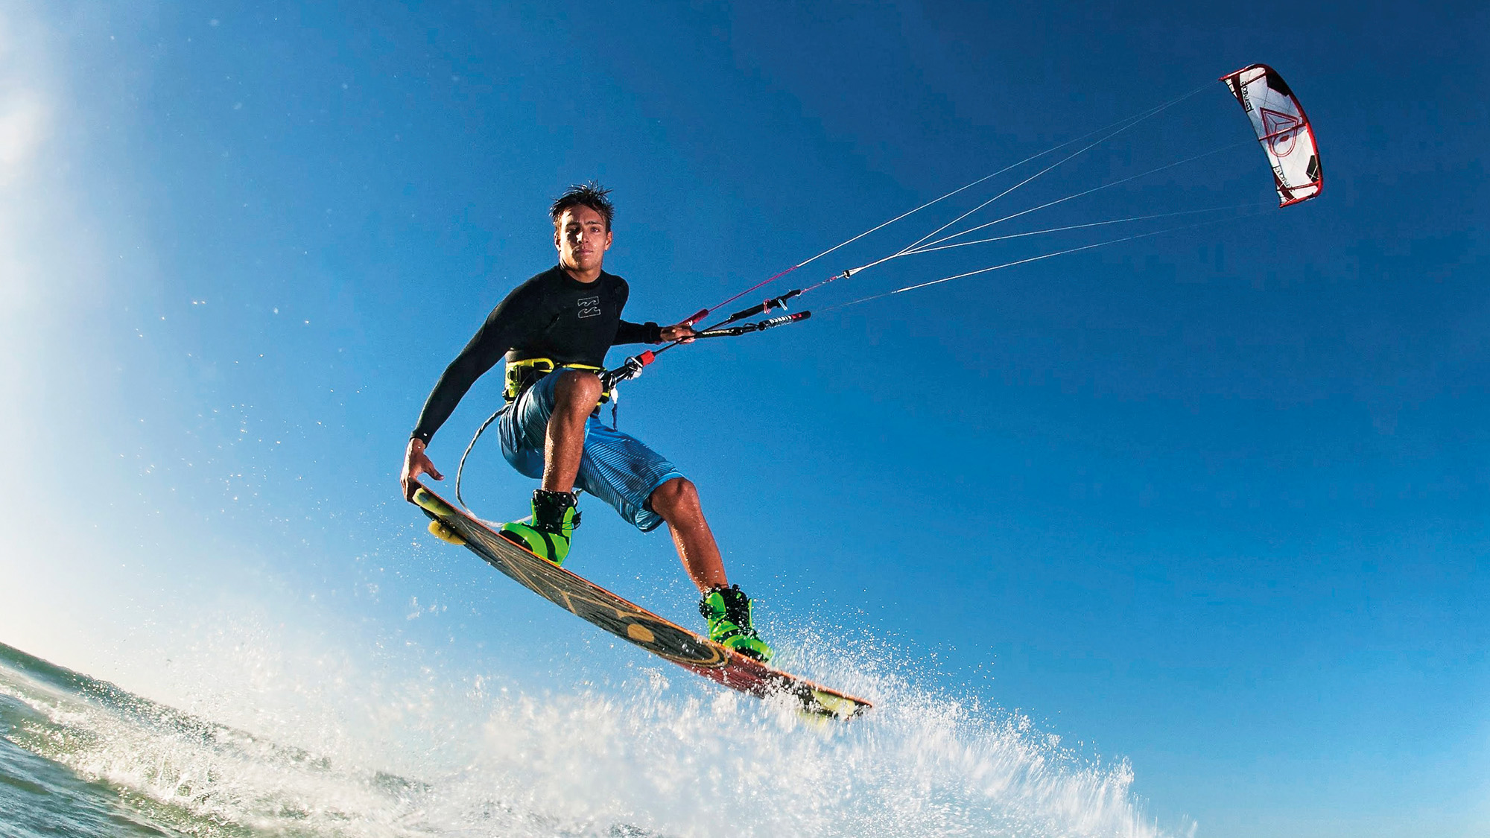
Northern Kiters

What We Offer
Lessons: - I like to learn / improve my Skills …. We Love To Teach.
- Taking kitesurfing lessons on Zanzibar is a great experience. Because of the perfect conditions, our latest premium material from Duotone kiteboarding and our professional, certified kite instructors. Choose the kitesurfing lessons that fit your needs, from beginning to advance. We love to teach you new tricks. Or take a private lesson and foiling or wave clinics. We are looking forward to help you progress on the endless blue water of Zanzibar.

Beginner Lessons: - I like to learn Kitesurfing
- If you never tried kitesurfing before you are at the right place to follow our beginner kitesurfing lessons. Northern kite Zanzibar is located at the best sport on Zanzibar, let our qualified and professional instructor take you out with the best equipment from Duotone to make your learning curve safe and fast. Choose from our options below for beginners.

Prices (All price are per Person)

Description | Information | Time | Price
Discover Level 1 | Learn how to fly a kite  Understand wind direction  Foil trainer, learn about power of kite & safety system  Water relaunching  No board involved | 3 hours | $180pp  $135pp Group price
Discover Level 2  Intermediate | Beginner to Intermediate  Down-wind body dragging & upwind body dragging  If the above is mastered, we do water start | 3 hours | $360pp  $270pp  Group
Discover Level 3 | Learn how to water start & ride both directions | 3 hours | $540pp  $405pp  Group
Supervised Rentals | Half day | 3 hours | $60 per hour
Private Coaching | Per hour / Per person |  | $60
Private Lesson (Refresher) | Improve my Skills | 1 hour | $60

Licensed Instructor
Lesson 1
After 3h into lesson
- Know safe wind directions and conditions for kiting, set up a kite and know the safety systems, first kite control and body drags.

Lesson 2/3
After 6h full course
- Body dragging and water launch, landing and launching the kite water start and riding first meters.

After the course
After full course, extra hours. Consistent riding in both directions, control speed by edging, know the right of way rules.
Kite Rental Equipment’s
- Full equipment (Kite + board + Harness) 1 day $70
- Full equipment ½ $45
- Full equipment 1 week $290
- Board 1 day $30
- Board ½ day $15
- Board 1 week $100
- Only harness $25
Important Information
You must be able to swim
- Kite lesson and courses: kitesurfing equipment and safety aids included in the price
- Rash vests, sunscreen and other items are available for purchase at the Zanzibar shops close to the office, It is recommended to wear a high SPF sunscreen at all times.
Payments
- Payment on site can be done in cash or major credit cards (5% processing fee applies for credit card)
Transfers
Area | One Way | Return
Nungwi / Kendwa | FOC | FOC
Pwani Mchangani | $30 | $60
Paje / Jambiani | $70 | $140

